Term 2 EYFS KIRFS to learn at home
- Continue to recognise and name 2D shapes (rectangles, squares, circles and triangles).
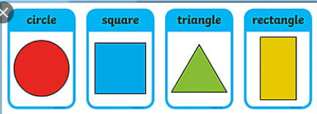

- Recognise and name 3D shapes (cubes, cuboids, pyramids and spheres).
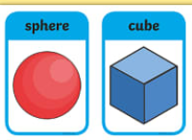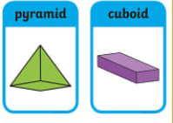
- Count to 20

- Recognise and write numerals 1, 2, 3, 4, 5

Term 2 Year 1 KIRFS to learn at home
- Read and write numbers from 1 to 20 in words.

- Continue with working out number bonds to all numbers within 10.

Know number bonds to 6
6 + 0
1+ 5
2 + 4
3+ 3

Know number bonds to 7
7 + 0
6 + 1
5 + 2
4 + 3

Know number bonds to 8
8 + 0
7 + 1
6 + 2
5 + 3
4 + 4

- Recognise and name 2D shapes (rectangles, squares, circles and triangles).

- Recognise and name 3D shapes (cubes, cuboids, pyramids and spheres).

Term 2 Year 2 KIRFS to learn at home
- Count forwards and backwards in 10s from any number
Eg 14, 24, 34, 44, 54 96, 86, 76, 66, 56

- Read and write numbers to 100 in words.

- Know the value of all coins and notes (Recap from Year 1)

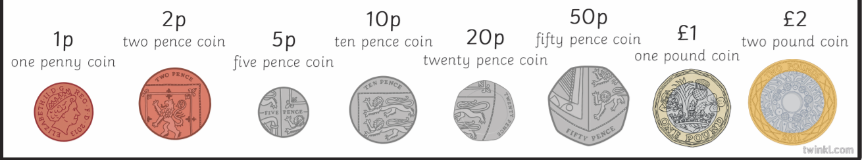
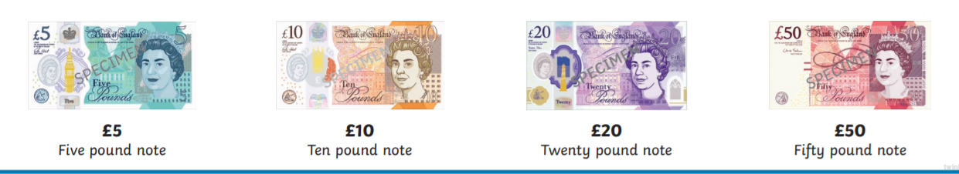
- Know multiplication and division facts for the 2, 5 and 10 times tables.

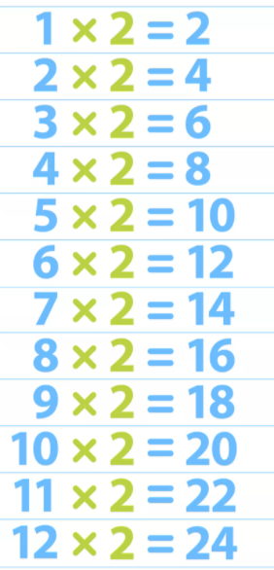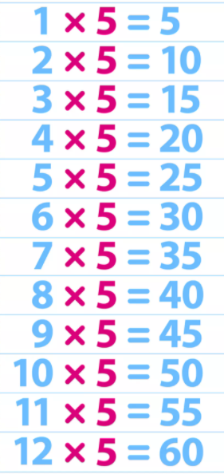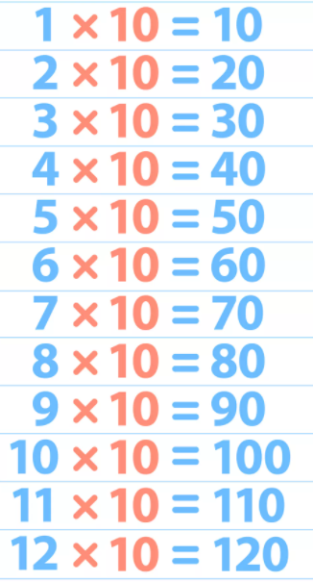

Learning times tables with a song helps some children – there are lots on you tube ! . Please also remember that you have a login for Times Tables Rockstars which has been set up for your child. Login is in their yellow reading record.

