Term 1 Key Instant Recall Facts for Year 4 | Key Instant Recall Facts to Revise from Year 3
- Count in 25s and 1,000s.  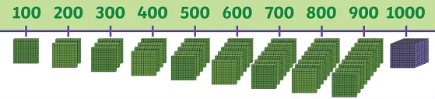  - Know 10 hundreds = 1,000. | - Count, from 0, in 3s to 36, 4s to 48 and 8s to 96.  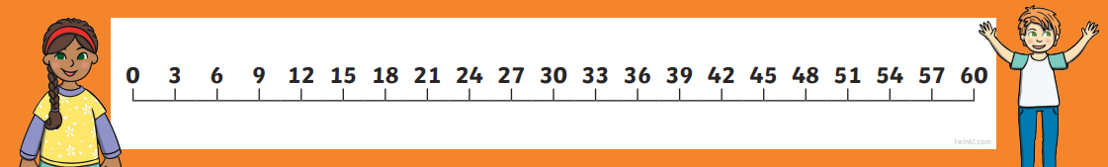  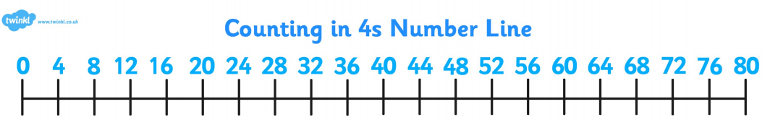  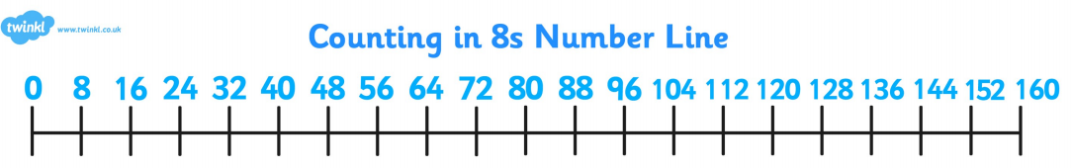  - Count in 50s and 100s.  - Read and write numbers to 1,000 in numerals and words.  - Know that there are 10 tens = 100.  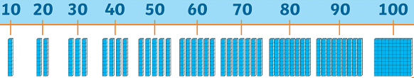  - Know number bonds to all numbers within 10.

