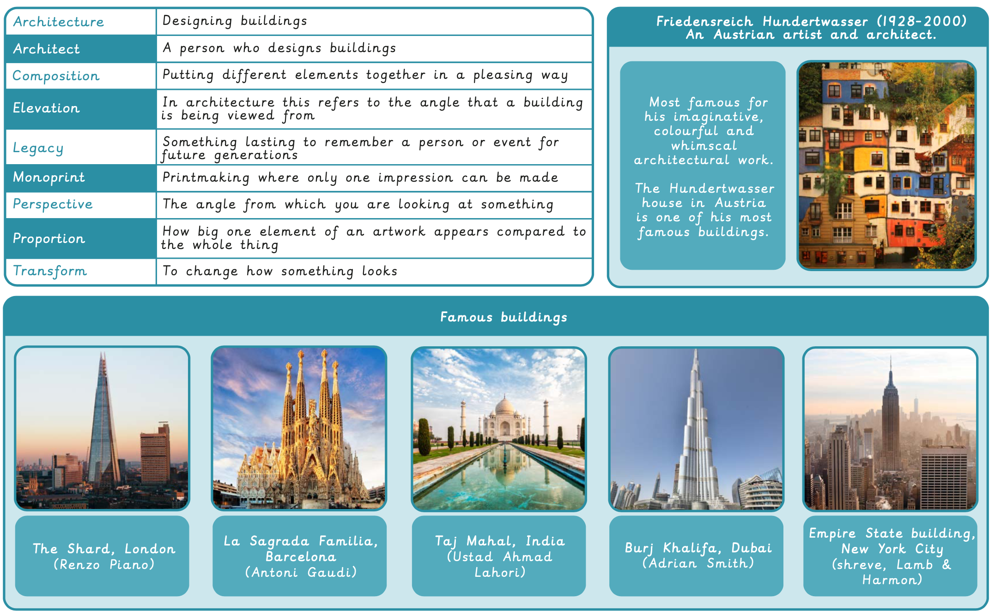
Art Term 1 Knowledge Organiser – Craft and Design: Architecture

