Term 2 Key Instant Recall Facts for Year 3 | Key Instant Recall Facts to Revise from Year 2
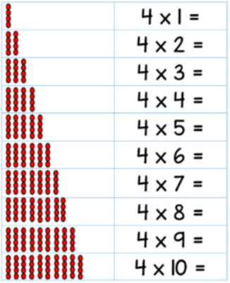  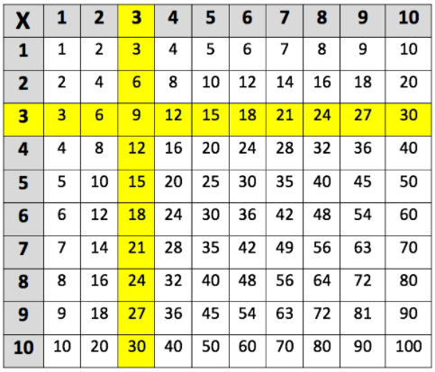  - Know multiplication and division facts for the 3, 4 and 8 times tables.  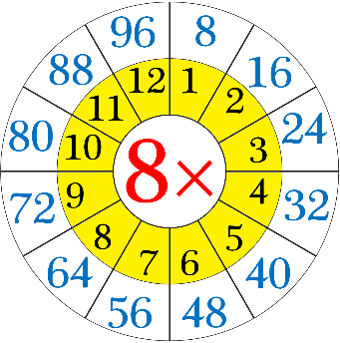  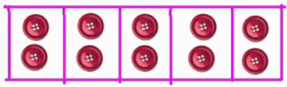  - Divide 10 by 2, 5 and 10 | 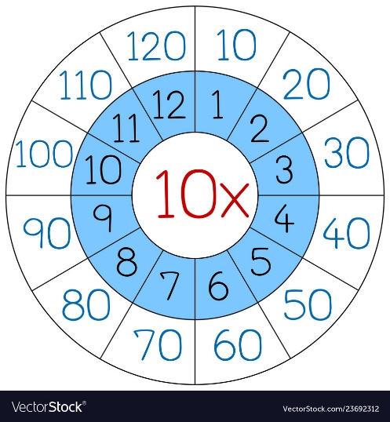  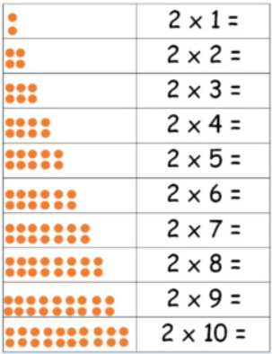  - Know multiplication and division facts for the 2, 5 and 10 times tables.  