Term 1 Key Instant Recall Facts for Year 3 | Key Instant Recall Facts to Revise from Year 2
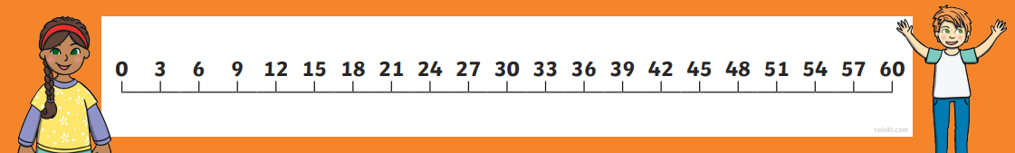  - Count, from 0, in 3s to 36, 4s to 48 and 8s to 96.  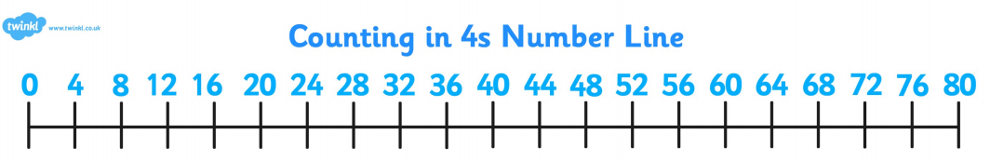  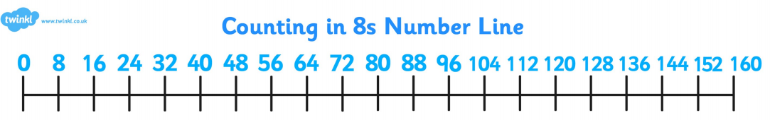  - Count in 50s and 100s.  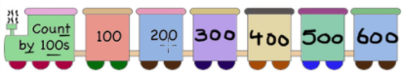  - Read and write numbers to 1,000 in numerals and words.  - Know that there are 10 tens = 100.  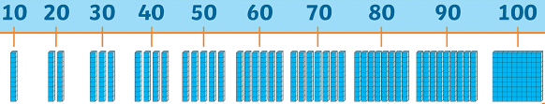 | - Recognise odd and even numbers.  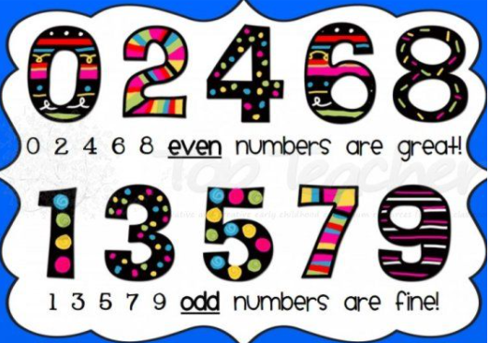  - Know number bonds to all numbers within 10.  - Know number bonds to 10.  