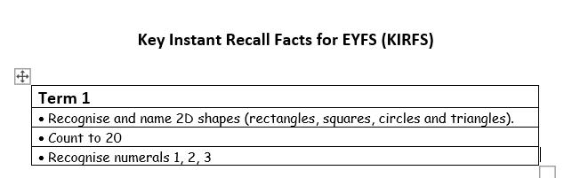

Useful websites and activities

2D Shape :
- Top marks has this free game which is quite nice for shape recognition
https://www.topmarks.co.uk/early-years/shape-monsters

- Spot shapes around the house – I can see a circle, can you find a circle ?
- Talk about shapes – what shape is that ? How do you know it is a triangle ?
Count to 20
- This can be incorporated into everyday games – counting as you walk down the garden, counting as you pick blackberries, counting as you play hide and seek, counting in the bath as they fill containers
- You tube song https://www.youtube.com/watch?v=eHbByA0fQnQ
Recognising 1 -3
- We use Numberblocks in school and the children find the videos very clear https://www.bbc.co.uk/iplayer/episodes/b08bzfnh/numberblocks
- Spotting and talking about numbers in the house and when you are out and about.

