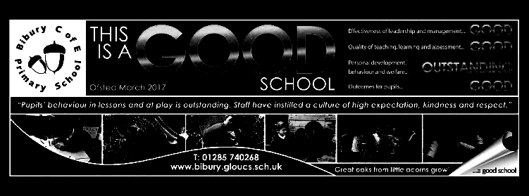

Dear Parents/Carers

Welcome back to a new academic year, in our newly-transformed school. We are adjusting to our new surroundings so it may take us a couple of weeks to settle into a routine, making full use of the new space available.

The Mighty Oaks will be housed in the ‘old’ key stage classroom for most of their learning. Sitting positions will be changed weekly to allow them the opportunity to work with different learning partners. We are also adopting the practice of ‘no hands up’, which encourages more discussion between pupils and engagement from the whole class – pairs will be invited to share their responses to questions after thinking/talking time. I will be working towards helping the pupils better understand all the characteristics of good learning so that they recognise that they can take greater responsibility for their own learning, thus developing greater independence and building confidence. This is linked to the idea of a ‘growth mindset’. To help them verbalise these ideas, we have 7 animal characters that embody good learning behaviours. You will find these at the end of this newsletter.

During our transition day, we talked about the ‘Star of the Week’ award and the pupils were invited to decide whether they wanted this to be reinstated for Mighty Oaks. They said that they sometimes felt that others were rewarded when they themselves had worked just as hard so we have agreed that I will continue to not select a ‘star’. During our first week, the pupils will be encouraged to determine how they can have the opportunity to celebrate their learning with the rest of the school and parents.

The children will be swimming for 15 weeks again over the first three terms of the year. In term 1, this will be on a Tuesday afternoon. As our session doesn’t finish until 3, this will mean a later end to the school day – this is likely to be between 3.30 and 3:40, and further information will be included with the swimming letter.

PE will take place on Thursday morning and Friday afternoon this term, so children will need to come into school wearing uniform on these days and will change into their kits for their PE lessons.

We continue this year to be able to teach key stage 2 in two separate classes for many subjects – they will be together as a key stage for Music, French (Mrs. Davies), Art, History, Geography, Computing (Miss Bevans) and PE (provided by Up and Under Sports).

I will be carrying out some assessments over the first couple of weeks to ensure that any gaps or strengths are identified– this will help me to plan the learning and any additional catch-up tasks.

As usual, I will be encouraging our older pupils to take on roles of responsibility in the school and will talk to them during the first few weeks about their interests and ideas for this. This, alongside their learning experiences, should help to build the independence that will help them to succeed in the future.

As always, I’m really looking forward to helping your lovely children with their learning. Please always feel free to contact me if you have any questions or concerns – the best way to do this is through the office.

Mrs. Davies

Mighty Oaks Term 1 2022-23

**Mathematics**

|  |
| --- |
| **Year 5**  Roman numerals  Place value in numbers to 1,000,000  Partition, Compare and order numbers  Round numbers  Mental strategies for add and subtract  Add and subtract numbers with more than 4 digits  Use rounding to check answers  Use inverse operations  Multi-step addition and subtraction problems  Identify multiples and common multiples  Find factors and common factors  Identify prime, square and cube numbers  **Year 6**  Roman numerals – revision  Place value, compare and order numbers to 10 million.  Round numbers to any integer  Negative numbers  Add and subtract any numbers – formal method  Identify common factors and multiples.  Use rules of divisibility  Identify primes, squares and cubed numbers.  Multiply up to a 4 digit number by 2 digits  Solve problems with multiplication  Strategies for division  Use the order of operations  Mental calculations and reason from known facts |

**English**

In reading, we will be using the acronym VIPERS to engage with texts. This term, most of these will either Greek myths or excerpts from our class reader, ‘Percy Jackson and the Lightning Thief’.

V: vocabulary I : Infer P: Predict E: Explain

R: Retrieve information S: Summarise

Our key grammar and punctuation skills for term 1 are:

1. Write with accurate use of all expected punctuation: full stops, capital letters, question marks, exclamation marks, commas in lists, apostrophes, speech marks, commas for clarity and to mark clauses.
2. Use hyphens to avoid ambiguity
3. Use expanded noun phrases across writing to convey complicated information concisely

We will also be working on developing our spelling and handwriting skills through weekly lessons/daily tasks. The spelling pattern for each week will provided for homework and set as practice on spelling shed.

In writing, we will be writing a set of instructions – How to defeat a mythical enemy and our own version of a Greek myth.

**Science ‘Electrifying.**

‘Electrifying’ What is electricity and how does it travel? We will learn the symbols for simple electrical components and how to construct circuit diagrams. We will carry out practical investigate work involving electrical circuits that we have constructed, asking and answering questions about the effects of adding, changing and removing components and also making suggestions about whether circuits will be successful. We will also construct circuits for specific purposes.

We will also learn about some of the electrical pioneers such as Thomas Edison and Michael Faraday.

For further information, see the Science Knowledge organiser.

**History Topic –The Ancient Greeks**

We will be learning about life in Ancient Greece. They will learn how to locate important locations in Ancient Greece on a map. They will explore the differences between life as a Spartan and an Athenian before learning about the importance of aspects of Ancient Greek life, such as the life of women, religion, myths and the Olympics. We will complete this unit by thinking about how the Ancient Greeks have impacted our modern-day life.

**R.E. – Why do Hindus want to be good?**

We will explore the belief that Brahman exists in everything and as ‘atman’ in all living things.

By learning about the ideas of karma and dharma, we will learn about the Hindu belief in the cycle of birth, death and rebirth and how these beliefs affect the way that they try to live their lives.

**R.S.H.E**

**Me and my relationships**

We will be exploring social relationships and friendships, including ways to work with others and how to be assertive when we don’t agree with ‘the crowd’.

**French - Salutations**

In this unit the children will learn how to: • Say ‘hello’ (formally and informally). • Say their name. • Ask how somebody is feeling and give a reply. • Say ‘goodbye’ and ‘see you soon’

**Music – Colour and music (linked to Hindu Holi festival)**

We will be using graphic scoring to represent the structure of music and creating our own compositions linked to colours using musical terms to describe our work.

.

**Computing**

In computing we will be learning how to stay safe online, learn how to search for information in a database and to be able to create an online database.

**Art/DT**

In art we will learn to draw from observation, create a print and draw from different perspectives. We will also learn about the role of an architect and consider why houses look the way they do and explore if there is scope to change and improve them.

**PE**

In P.E. this term, the children will be learning the skills of handball and hockey. They will also have 5 weeks of swimming lessons.

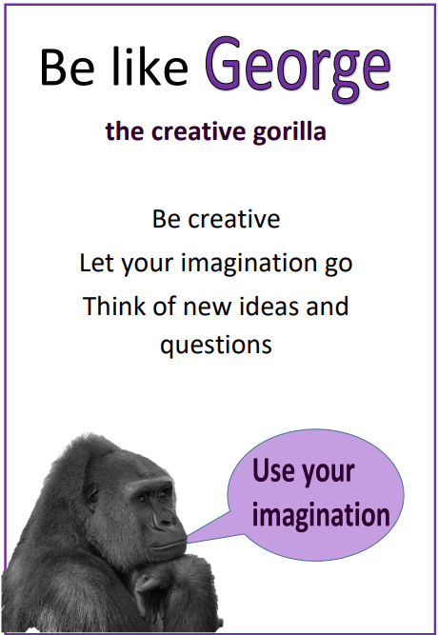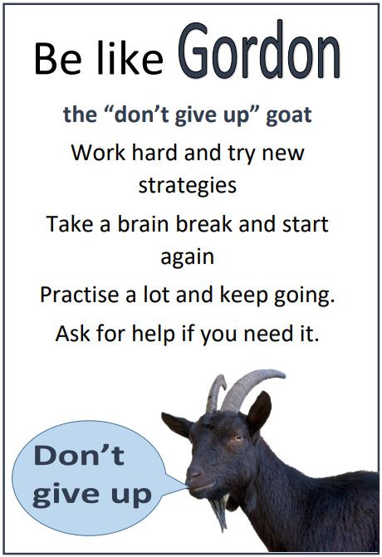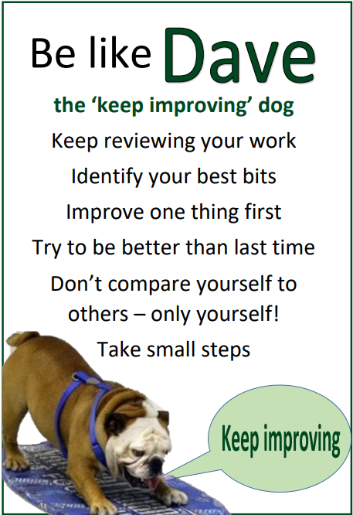

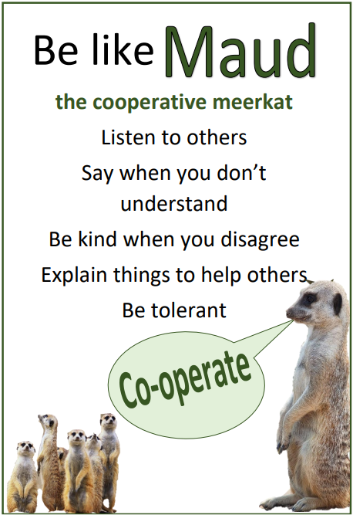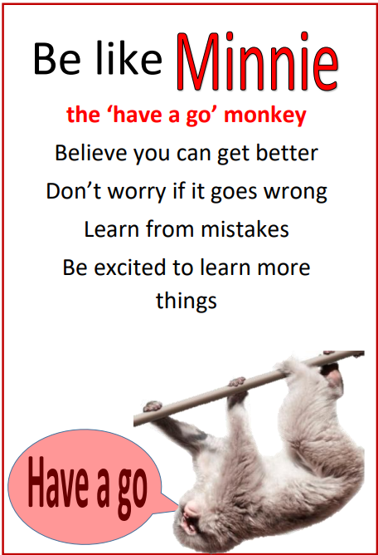

Meet the characters that will help to become better and more independent learners.