KEY INSTANT RECALL FACTS FOR TERM 4
Year 6
Times tables and key facts from previous terms remain a priority if not known. | Know fraction, percentage and decimal equivalents.  Use known equivalents to find others – e.g. $\frac{1}{4}$ = 0.25 so $\frac{3}{4}$ = 0.75  Pupils will have learned the fraction and decimal equivalents last term – we now add percentages.  $$\frac{1}{2}$$ $$\frac{5}{10}$$ 0.5 50%  $$\frac{1}{4}$$ $$\frac{25}{100}$$ 0.25 25%  $$\frac{1}{5}$$ $$\frac{2}{10}$$ 0.2 20%  $$\frac{1}{8}$$ $$\frac{125}{1000}$$ 0.125 12.5%  $$\frac{1}{3}$$ 0.33^{r} 33.33%  $$\frac{1}{10}$$ 0.1 10%  $$\frac{1}{100}$$ 0.01 1%  $$\frac{1}{20}$$ $$\frac{5}{100}$$ 0.05 5%  $$\frac{3}{4}$$ $$\frac{75}{100}$$ 0.75 75%  $$\frac{1}{25}$$ $$\frac{4}{100}$$ 0.04 4%
These hundred squares help to illustrate why these are equivalent. Pupils should know that ‘per cent’ means ‘in every hundred’. | 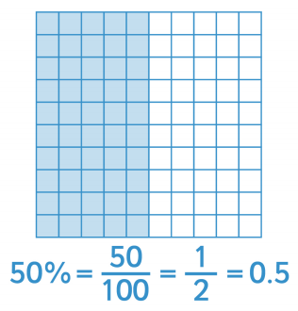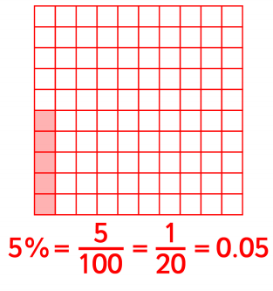

Know the conversions between metric units of measure | Length 10mm = 1cm 100cm = 1m 1000mm = 1m 1000m = 1km 1mm = 0.1cm 1mm = 0.001m 1cm = 0.01m 1m = 0.001km 10cm = 0.1m 10m = 0.01km 100m = 0.1km Capacity 1000ml = 1 litre 100ml = 1cl 1ml = 0.001l 10ml = 0.01l 100ml = 0.1l  Mass  1000g = 1kg  1000kg = 1 tonne  1g = 0.001kg  10g = 0.01kg  100g = 0.1kg

Thinking about capacity can often help to make sense of these conversions.
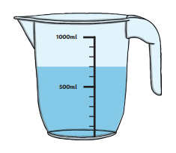
This jug has a capacity of 1000ml, which is one litre
You can see that it has got 700ml of water in it.
As the scale is marked in tenths, you can see that 700ml is the same as seven tenths of a litre.
Seven tenths is written as 0.7, so 700ml = 0.7l

