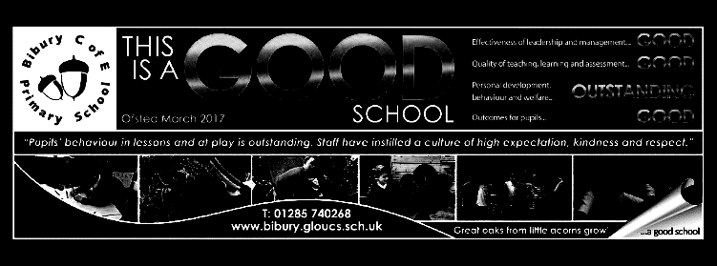

Dear Parents/Carers,

I hope you all enjoyed your October holiday and that the children are looking forward to getting back to their learning.

I have changed the day when written homework is to be handed in to Tuesday, so as to be in line with Oaks Class (for parents who have children in both groups, this should be easier). This means that new homework tasks will be given out on Wednesdays. Spelling tests will continue to take place on Monday, when new weekly spellings will be given, so online spelling practice for these words will remain Monday to Sunday.

Our maths Key Instant Recall Facts for this term are split into two main parts: prime numbers and square numbers which children need to understand and recognise; being able to divide 1 by 2,4, 5 and 10 - this introduces the idea of decimals and will help them to read decimal scales and make conversions between units of measurement later in the year. Year 6 also need to learn and use the order of operations. Please also support your child to continue to practise recall of multiplication and division facts as it is vital that this information can be brought quickly and easily to mind. There are links to online maths games on our Padlet page <https://padlet.com/edavies12/mathswall>

The run up to Christmas is always a busy and joyful time and we have lots of activities planned for this term. On Sunday, 13th November, the children have been invited to take part in the Remembrance Service at St. Mary’s Church, for which we will be learning a song, ‘Prayer for Peace’. I do hope as many children as possible will be able to take part in this.

I will be running two musical clubs this term and I am pleased that so many children have signed up to learn to play the recorder at lunchtimes. Singing club will take place after school on Tuesday afternoon (until 4.15) so please let the office know if your child wishes to take part.

If you have any questions or concerns about your child’s learning, please do not hesitate to get in touch.

Mrs. Davies

Mighty Oaks Term 2 2022-23

**English**

In reading, we continue to use the acronym VIPERs to explore and extract information from texts.

V: vocabulary I : Infer P: Predict E: Explain

R: Retrieve information S: Summarise

Our key grammar and punctuation skills for term 1 are:

1. Write in complex sentences, using commas for clarity.
2. Recognise nouns, pronouns, verbs, adjectives, prepositions.
3. Use different types of adverb to add information to sentences.

We will also be continuing our spelling and handwriting skills through weekly lessons/daily tasks. The spelling pattern for each week will provided for homework and set as practice on spelling shed.

Our first writing task of the term is based on the wonderful wordless book ‘The Arrival’, which links with our history theme of ‘Journeys’.

Later in the term, we will writing

persuasive texts linked to topical issues.

**Mathematics**

|  |
| --- |
| **Year 5**  Identify multiples and common multiples  Find factors and common factors  Identify prime, square and cube numbers  Multiples of 10,100,100  Find equivalents of unit and non-unit fractions  Recognise equivalent fractions  Convert between improper fractions and mixed numbers  Compare and order fractions  Add fractions and mixed numbers  Subtract fractions and mixed numbers  **Year 6**  Strategies for division  Use the order of operations  Mental calculations and reason from known facts  Equivalent fractions and simplifying fractions  Compare and order fractions  Add and subtract fractions and mixed numbers  Multi-step problems with fractions  Multiply fractions by integers and fractions  Divide fractions by an integer  Fractions of amounts  Find the whole from a given fraction.  Convert metric measures  Calculate with metric measures |

**Science ‘Out of this world’**

This term, we will learning about the Earth and its place in the solar system. This will include the order of planets, orbits, day and night, seasonal change and the changing appearance of the moon. For more information, please see the knowledge organiser.

**History Topic – What makes people go on a journey?**

We will explore the question of why people go on a journey, and look at five very different types of journey in depth. The journeys selected span from the Tudor period to those undertaken today by refugees. The children begin by studying the voyages of Walter Raleigh, then the voyage of the Irish 3rd class passengers on the Titanic, before learning about the Kindertransport in World War Two and the voyage of the Empire Windrush. Finally, they will examine why refugees make dangerous journeys today.

**R.E. – Why do Hindus want to be good?**

We will conclude our study of Hinduism by exploring how Hindus believe that they have duties to perform at different times in their lives.

We will look at how their beliefs are linked to non-violence, vegetarianism and support for charitable organisations.

We will also explore the festival of Diwali through a dance workshop.

**R.S.H.E**

**Keeping safe**

We will be reminded about internet safety before learning about substances that are harmful to health and the laws surrounding these.

**French – Presenting Myself**

Building on our learning from last term, pupils will learn to ask someone their name, ask and answer questions ‘How old are you?’ and ‘Where do you live?’ in French., and saying ‘Happy Christmas’. We will also be learning/revising numbers in French to 20.

**Music – The Chinese pentatonic scale (and singing)**

We will be listening to Chinese music and exploring the pentatonic scale to create and write scores for melodies. We will also be learning to sing a range of songs.

.

**Computing**

Mighty Oaks will be focusing on Blogging this term. They will be expected to identify the purpose of writing a blog, the features of a successful blog and will eventually begin to plan a theme and content for their own blog. Before they do this, the children will need to understand how to write a blog and a blog post and how to contribute to an existing blog.

**Art/DT - Textiles**

Children will learn how textiles are used to make containers - e.g., purses, wallets and belt bags are designed for different purposes and different users. They will design patterns/templates, and join and reinforce fabrics. This is where they will begin to develop their designing skills when evaluating products and use this information to generate their own ideas.

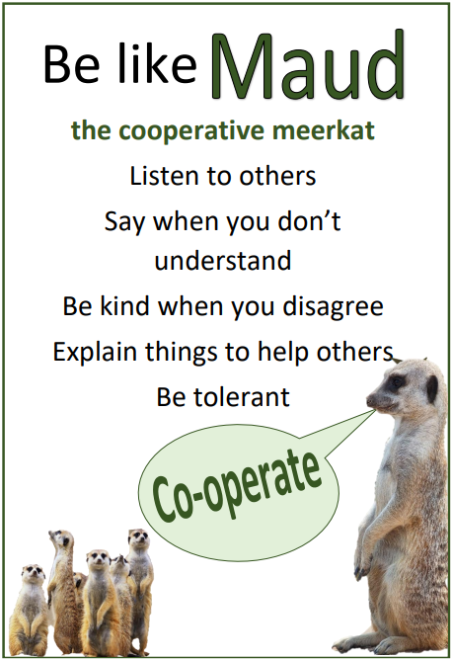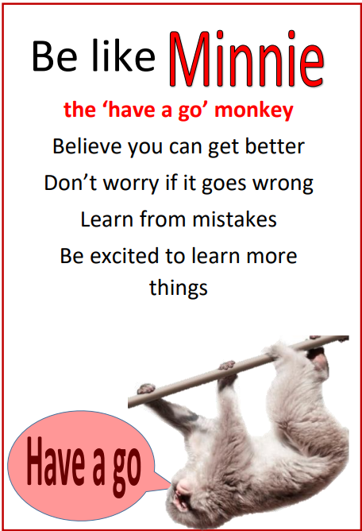

Meet the characters that will help to become better and more independent learners.