Year 1 Term 1 Key Instant Recall Facts ( KIRFS)
- Read and write numbers from 1 to 20 in numerals ( recap from EYFS year)

- Identify one more and one less than any number (to 20) ( recap from EYFS year)

- Recognise ordinal numbers (1st, 2nd, 3rd) ( recap from EYFS year)
Say to your child – who is first, who is second, who is third when opportunities arise

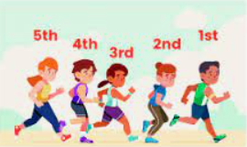

- Be able to work out number bonds to all numbers within 10.
