Year 6 Term 6 Key Instant Recall Facts

Properties of Shapes  - Know the names of all parts of a circle (radius, diameter, circumference).  - Know that the diameter is double the radius.  - Know that the radius is half the diameter. | 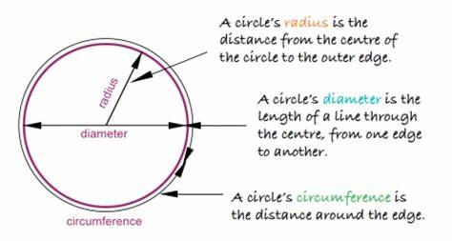
Angles in shapes  - Know that the interior angles of any triangle add to 180º  - Know that the interior angles of any quadrilateral add to 360º. | 