History Term 1 Knowledge Organiser – Ancient Greece
Key Vocabulary
Ancient | Something from a very long time ago.
Democracy | Democracy is a system where the citizens of a country or state are involved in the way it is run.
City states | Small areas that ancient Greece was divided into, each with their own governments, laws and army.
Primary source | Information and objects that come from the time being studied.
Secondary source | Interpretations of information and objects which are produced after the time being studied.
Myth | A legend or story produced by the religion and culture of ancient Greece.
Sparta | A prominent city-state in Laconia, in ancient Greece.
Athens | Athens was the largest and most influential of the Greek city-states
Parthenon | The Parthenon is a former temple on the Athenian Acropolis, Greece, BC.
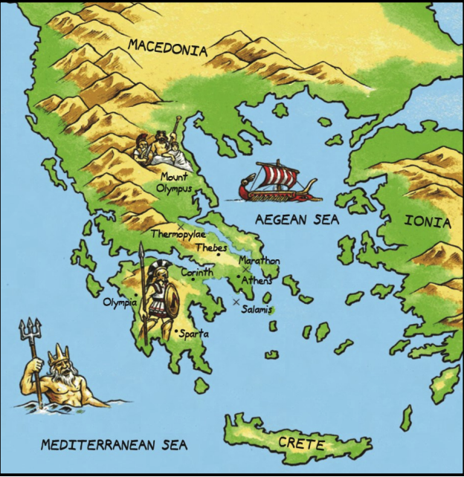
Olympic Games
- The first recorded Games was in 776 BC, in Olympia.
- The event was part of a festival to honour the Greek god, Zeus.
- Women were not allowed to compete in the Olympics. This was because ancient Greek women were not treated as equals to men and had fewer freedoms.
- Events included boxing, wrestling, running and chariot racing.

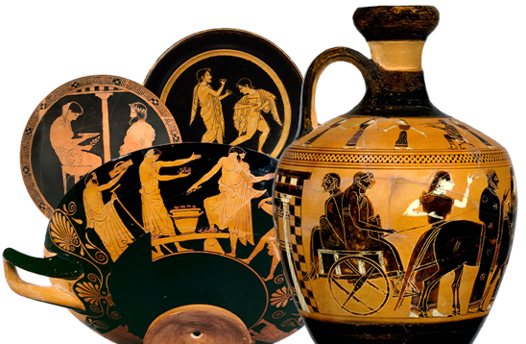
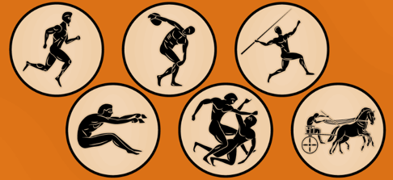
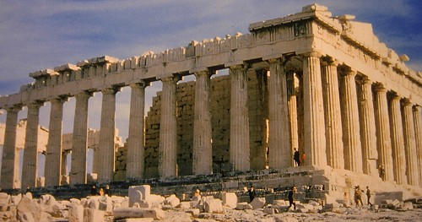
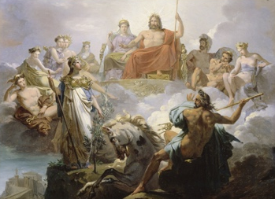
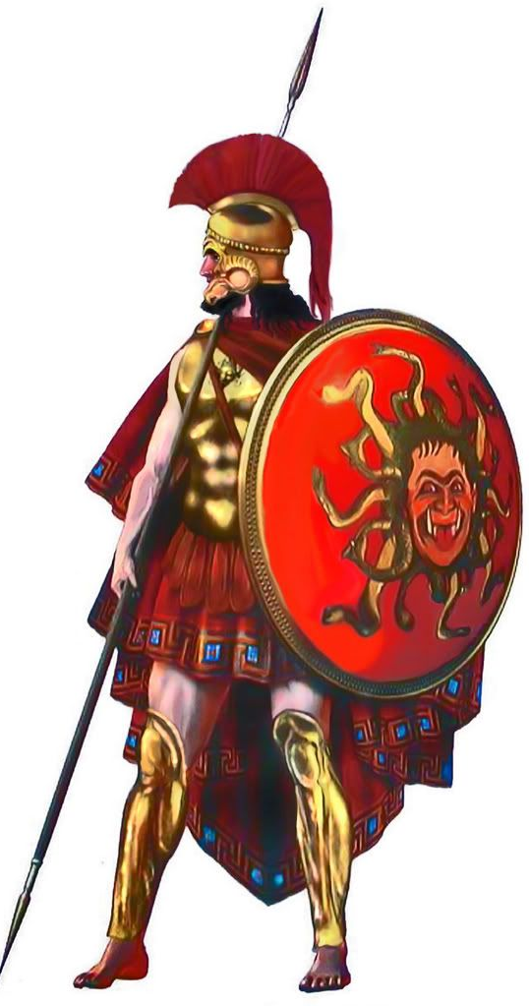
Religion and Beliefs
- The ancient Greeks believed in many different gods and goddesses.
- Each god/goddess represented a certain aspect of humanity and each was responsible for certain parts of life too.
- It is believed that the 12 most powerful gods lived on Mount Olympus.

