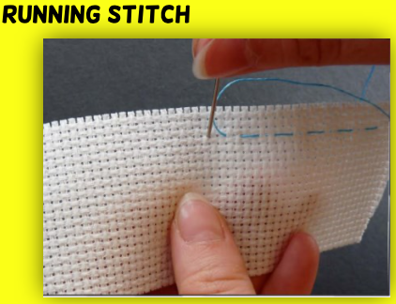
Design and Technology Term 2 Knowledge Organiser – Money Containers
To create a money container, we will:
Look carefully at other designs and think about… Who is this designed for? What material is used? How does it fasten? How is it decorated? Were they practical or design choices?
Using what you’ve seen, create your own design. Draw up a template using newspaper to test out your design!
Decide on which stitches you will use, how you will fasten and decorate your container.
Create your money container and then evaluate your design—what went well and what could be even better?

Key Vocabulary
Money Container | A place to hold or keep money.
Wallet / Purse | A small container that is commonly used to hold money.
Back stitch | Many stitches which create a continuous line of thread
Running Stitch | The thread is sewn in and out of the 2 pieces of material to join them together.
Fastener | Something that is used to keep something closed e.g., zip, button, popper, Velcro.
Fabric | A soft material used to make clothes and other items.
Design | To plan and draw an idea thinking about their target audience.
Evaluate | To look at their creation and thinking about things that have worked out well and those they would change to improve next time.
Seam | A line of stitching that joins pieces of fabrics together.
Stitch | A single piece of thread visible after it has been sewn.

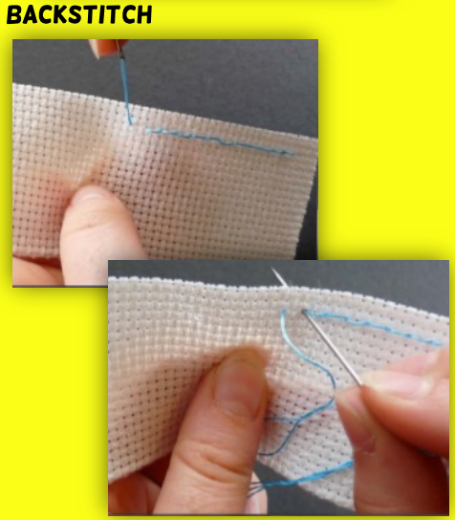

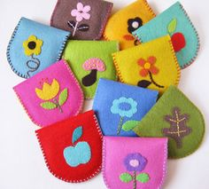
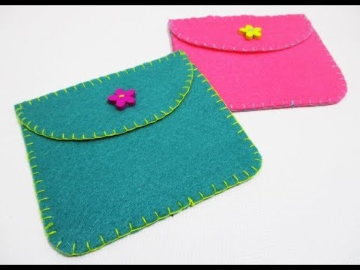
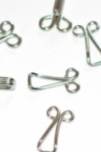
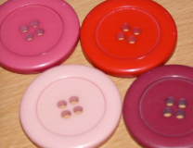
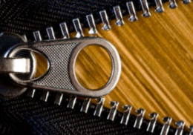
Fastenings are attached to allow something to be opened and closed easily. When the fastening is closed, it is meant to keep everything inside safe and contained. Types of fastenings include Velcro, beads, buttons, hook and eyes, paperclips and zips.

