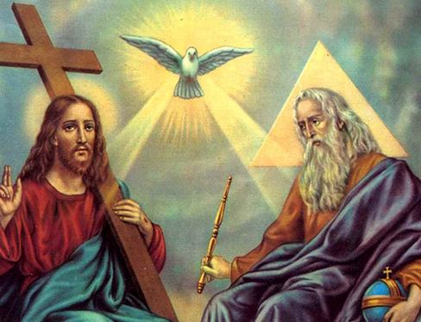
RE Term 2 Knowledge Organiser – What is the ‘Trinity’ and why is it important for Christians?
Christians believe God is Trinity:
- Father, Son and Holy Spirit. One God in three parts or three in one.
- Christians believe The Father creates; He sends the Son who saves His people; the Son sends the Holy Spirit to His followers.
- Christians spend their whole lives learning more and more about God.
- Christians believe the Holy Spirit is God’s power at work in the world and in their lives today, enabling them to follow Jesus.
Key Vocabulary
Trinity | The state of being three. Here, God as Father, Son and Holy Spirit
Father | First person of The Trinity. God the Creator of the Universe and all in it
Son | Second person of the Trinity. Jesus, God in human flesh.
The Holy Spirit | Third person of the Trinity. God in the form of an unseen power. Part of God that lives in Christians.
Baptism | Religious rite of sprinkling water onto a person’s forehead or immersing them in water. Welcoming a person into the Christian Church.
Prayer | Spiritual communication between man and God. Talking to God. Giving thanks and asking for help.
Blessing | Form of prayer, asking for God’s favour and protection.
Gospel | The teaching or revelation of Christ.
Incarnation | A person who embodies a deity, spirit of quality in flesh.
Symbol | Mark or picture representing something else, e.g., the dove is a symbol of the Holy Spirit.
Worship | Ways for people to show how much God is worth to them.

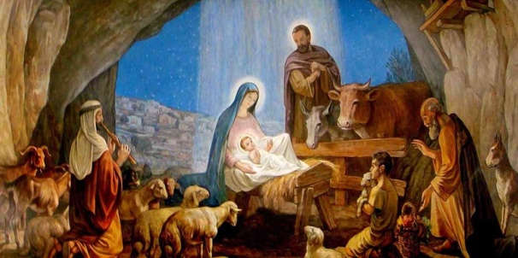
Pupils should know:
- Christians believe God is Trinity: Father, Son and Holy Spirit.
- Christians believe The Father creates; he sends the Son who saves his people; the Son sends the Holy Spirit to his followers.
- Christians find that understanding God is challenging; people spend their whole lives learning more and more about God.
- Christians really want to try to understand God better and so try to describe God using symbols, similes and metaphors, in song, story, poems and art.
- Christians worship God as Trinity. It is a huge idea to grasp and Christians have created art to help to express this belief.
- Christians believe the Holy Spirit is God’s power at work in the world and in their lives today, enabling them to follow Jesus.

