RE Term 1 Knowledge Organiser – What do Hindus believe God is like?
Key Vocabulary
Atman | Means individual soul or essence.
Aum | Symbolises the Universe and the ultimate reality. It is the most important Hindu symbols.
Brahman | The God of creation and supreme spirit of all life.
Deity | A god or goddess.
Karma | A belief that good or bad actions determine the future of an individual's existence.
Mandir | A Hindu temple.
Moksha | The result of being released from the cycle of rebirth.
Murti | A sacred image or depiction of a deity.
Reincarnation | A religious belief that the soul or spirit, after biological death, begins a new life.
Samsara | The process of reincarnation (continuous cycle in which the soul is reborn over and over again.)
Trimurti | The three aspects of the universal supreme God (Brahman, Vishnu and Shiva).
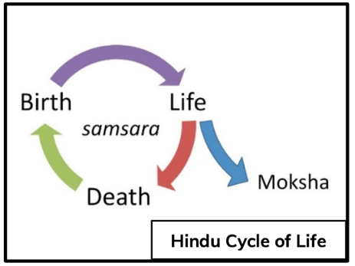
Hindu Gods and Goddesses.
The Trimurti (the Hindu Trinity) consists of Brahman the Creator, Vishnu the Preserver, and Shiva the Destroyer.

Their feminine counterparts are Saraswati, the wife of Brahma, Lakshmi, the wife of Vishnu, and Shakti (or Parvati), the wife of Shiva.

Hinduism is the oldest of the world’s religions. It is now practised all over the world but originated in Southeast Asia.
It is a mix of different beliefs, cultures and traditions dating back over 4000 years.

Diwali is an important Hindu festival.
It is known as the ‘festival of light’ and celebrates the victory of good over evil, light over darkness and knowledge over ignorance.
It is celebrated over five days.
- Dhanteras (day of fortune)
- Naraka Chaturdasi (day of knowledge)
- Diwali (day of light)
- Padwa (New Year)
- Bhai Dooj (day of love between siblings)

