Term 2 Key Instant Recall Facts for Year 4 | Key Instant Recall Facts to Revise from Year 3
- Know multiplication and division facts for all times tables to 12 x 12.  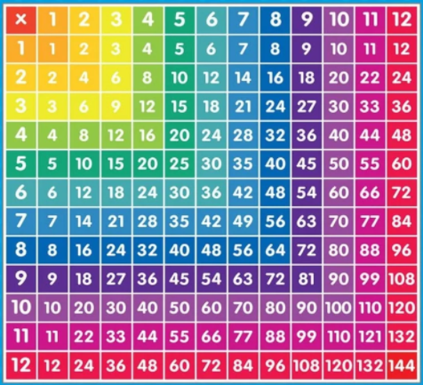  - Divide 1,000 by 2, 4, 5, 10 (to support reading scales).  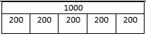  1000  500 500  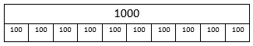  1000  250 250 250 250 | 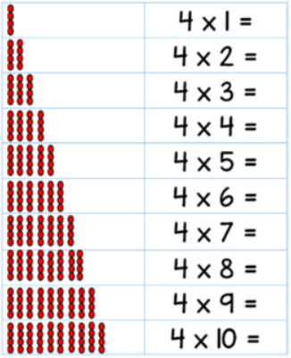  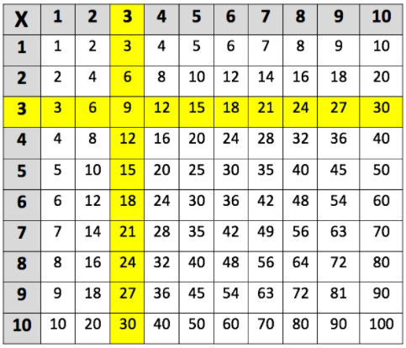  - Know multiplication and division facts for the 3, 4 and 8 times tables.  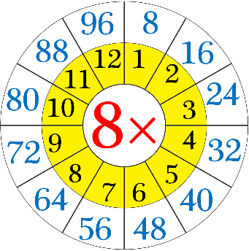  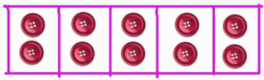  - Divide 10 by 2, 5 and 10

